ACNA West – Bishops Retreat 2025
Zimmerman House(s)
Albuquerque, NM
Menees (11), Lowenfield (13), Ruch (13), Zimmerman (14), Andrews (15), Reed (19), Tighe (21), Worley (24), Ashey (25)

MONDAY 03.17.25
4:00pm Arrive

5:00pm EP/song

6:00pm Dinner

7:00pm Check in (3)

8:30pm Compline/Song/
Group Intercession

TUESDAY 03.18.25
8:00am Breakfast
9:00am MP/Song
9:30am Check In (3)
11:00am Break
11:30am Initiative #1: ExChap
Bp. Menees
Intercess; Set Goals

12:15pm MidP/Song/Lunch

1:15pm Initiative #2: MscoOff
Bp. Reed
Intercess; Set Goals

2:00pm Initiative #3: ChPlant
Bp. Andrews
Intercess; Set Goals
2:45pm Outing

5:30pm EP/Song

6:00pm Dinner

7:00pm Check In – 3

8:30pm Compline/Song/
Group Intercession

WEDNESDAY 03.19.25
8:00am Breakfast
9:00am Holy Eucharist
10:00am Initiative #4: LayTrng
Bp. Lowenfield
Intercess; Set Goals

11:00am Initiative #5: BpC/Mgmt
Bp. Andrews
Intercess

12:00pm MidP/Lunch

1:00pm Initiative #6: TheoEd
Bp. Andrews
Intercess; Set Goals

2:00pm Initiative #7: Rplction
Discuss Regionalization

2:30pm Outing

5:30pm EP/Song

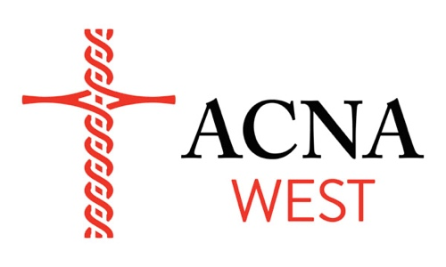
6:00pm Dinner

7:00pm Song/Intercession/
Blue Sky Sharing

9:00pm Compline
THURSDAY 03.20.25
8:00am Breakfast
9:00am MP/Song

9:30am Set Visitation Cldr
New 2025 Initiatives
Hispanic Min Suprt
Renewal Min
Deployment Off
LeadDev apost ldrs
Wrshp Rsrcs Clrnghse
Affirm Accord
College/Province
Debrief our time

11:30am Prayer/Praise/MidP

12:00pm Lunch

12:45pm Pack

1:00pm Travel
Go in Peace

